Lesson Plan Template for Elementary Field Experience
Student Name: Angie Kim
Grade Level: 4th
School and CI Name: Thomas Jefferson Elementary School/ Rob Carey
Date of Lesson Enactment: October 16, 2015

Topic: Identify Stated Main Idea and Supporting Details
Essential Questions: (What question(s) will students grapple with as they learn through this lesson?)
- Why is it important to identify a main idea and supporting details? How does this help you as a reader?
Primary Content Objectives:
Students will know: (facts/information)
- The main idea is the most important idea from the paragraph or story.
- A main idea is what a paragraph, article, or a story is about.
- Sometimes the author states the main idea directly. Other times readers use clues (in fiction) or evidence (in nonfiction) to identify the main idea.
Students will understand: (big ideas)
- That it is important to identify the main idea of a text in order to understand what they are reading.
Students will be able to do: (skills and behaviors)
- Identify the main idea or theme of a text and summarize using supporting details.
- Ask questions about a text
- Answer text-dependent questions about the main idea and supporting details.

Related state or national standards: (Examples include State Standards of Learning, Common Core State Standards, Next Generation Science Standards or National Curriculum Standards for Social Studies)
VSOL 4.6 The student will read and demonstrate comprehension of nonfiction texts.
d) Identify the main idea.
e) Summarize supporting details.
Assessment: (How (and when) will students be assessed? What evidence will you collect to determine whether students have met the lesson objectives? Will the assessment(s) be a pre-assessment (diagnostic), formative (ongoing feedback) or summative?)
- Formative assessment: Throughout the lesson, the teacher will be assessing students informally through observations. Watch for participation during ongoing discussions to see if they can identify the main idea and supporting details. Note students who demonstrate understanding of the concepts and those who seem to struggle. Use appropriate responsive prompting to help those who need modeling or additional guidance, or to validate students who demonstrate mastery. Based on observations, teacher will identify students who may need additional explicit reinforcement of the strategy during small group instruction or intervention time. Scaffold students toward independent use of the strategy.
- Summative assessment: During this lesson, students will be asked to complete the main idea graphic organizer (See appendix A) and to sort main ideas with the appropriate supporting details (See appendix C). Teacher will then use the graphic organizer and the sorting activity to assess, evaluate, and create a differentiated lesson on the areas of improvement.
Materials and Resources:
- Graphic organizers for each student (See Appendix A)
- A nonfiction passage (See Appendix B)
- Main idea and supporting details sorts (See Appendix C)
- Main idea and supporting details sorts answer key (See Appendix D)
- Chart paper

Key Vocabulary and Definitions:
- Main idea: what a paragraph, article, or a story is about; it gives you the most important information about the topic.
- Supporting details: Specific information that tells more about the main idea

Lesson Procedures:
- Introduction and goal orientation:
Teacher will explain the objectives of this lesson. Say, “We are going to practice identifying the main idea and supporting details in a nonfiction text. This is an important strategy because it helps you understand what you’re reading. ” [3-4 min]
- Connecting to prior knowledge and experiences: (Questions or activities that help students make links)
Say, “I have a nonfiction text here. What do you think this passage is about?” Some potential responses may be “Human body and brain!” and “What a human body and brain do?” Then say, “Great responses! Well, if you look at the title, you can easily notice that this passage is about human body and brain. Considering that it’s a nonfiction text, do you think it will give you facts or unrealistic information?” Check in with students and say, “Since nonfiction refers to a text that is written based on facts, real events, and real people, it will give you true information. Remember we learned what facts were during our facts vs. opinions lesson last week?” Wait for students’ responses. Say, “Every text you read will have a main idea and supporting details. We’ll be using a nonfiction text today. Who knows what main idea is?” Take a few responses from students. Some potential responses may be, “Main idea is what the story is about.” and “I think main idea is the most important idea in the story because main means the most important.” After taking responses from students, explain what main idea is. Then ask, “What are supporting details?” After taking responses from students, say, “Supporting details are specific information that support and prove the main idea. Great! Now, I’m going to read this passage aloud. In the graphic organizer, record the main idea and at least three details that you think support the main idea.” Read aloud the passage to students. After reading, say, “Now, think about the content of this passage. What was it mostly about?” Take a few responses from students. Explain, “The passage is mostly about the main parts of the brain and their functions. Let’s look closely at the text and find details that support this main idea. Sometimes details support a main idea by giving examples. Other times, they tell more about the main idea. Authors provide details to help readers understand a main idea. What details helped you learn about the main parts of the brain and their functions?” Check what students have written in their graphic organizer and record their responses on a chart paper during discussions. [10 min]
- Tasks and activities: (What challenging tasks and activities will students engage in as they construct knowledge, learn new skills or behaviors and develop understandings?)
Say, “Now that we know what a main idea and supporting details are, we’ll practice identifying them in a text.” Hand out the main idea and supporting details sort (See Appendix C). Say, “Your goal is to identify main ideas and their supporting details. There are 4 main ideas in the set and each main idea is supported by 3 details. First, place the 4 main ideas on the top as headers and figure out which 3 details support each main idea. Remember, there are sentences that are relevant to a topic but do not support any of the main ideas. When you find one like that, you can simply place it where it says ‘non-examples.’” Teacher will constantly make observations and check in with each student. Have each student support his or her decision with reasoning. [20 min]
- Closure: (How will you wrap up the lesson and reinforce key ideas? Closure may include some form of assessment or exit slip)
After approximately 15 minutes, ask students to tell the 4 main ideas and why they believed they were main ideas. Also, ask each student to give one supporting detail for each main idea. Reiterate the definition of main idea and supporting details as you have discussions with students. Say, “Most coffees cost under five dollars a pound tells you the cost of coffees whereas too much coffee can cause the hands to shake proves that coffees can be bad for people. Just like this example is showing, a main idea gives you the most important information about the topic and supporting details give you specific information that tells more about the main idea.” Collect their graphic organizers and evaluate their responses as an assessment. [5 min]
Differentiation: How will you modify the content (what is learned), the process (how the content is mastered) or product (how the learning is observed and evaluated) to support diverse learners? Describe additional supports that can be used for re-teaching if needed, and a challenging extension for students for demonstrate mastery quickly or show evidence of a lot of prior knowledge.
- Topic can be chosen based on student interest or readiness level, with supporting pictures.
- When asking students to write the main idea and supporting details in their own words, provide the following academic sentence frames to support ELLS and struggling students:
  - The main idea was __________.
  - The details that support the main idea are _______________.

Appendix A- Main idea graphic organizer
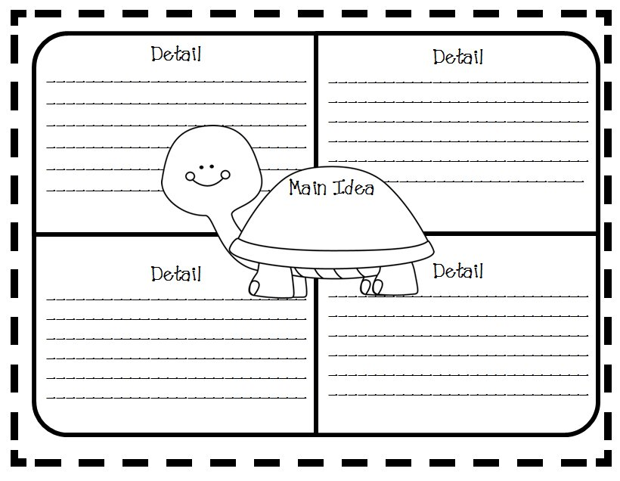
Appendix B- Nonfiction passage
The Human Body The Human Brain
The brain is the control center for the entire human body. Everything the body does, every action, is initiated1 in the brain. The brain works a lot like a computer. It constantly receives information. It analyzes and processes the information. Then it responds instantly by sending out signals that cause the body to take action. When you lift your left pinky finger, a signal first went through your brain to lift that finger. You stand up and already the signal to stand up went through the brain. There is nothing you do that does not involve your brain. Your breathing, circulation2, five senses, everything originates in the brain.
The brain is split up into three main parts: the cerebrum, the cerebellum and the brain stem. They are each responsible for different functions in your body.
The cerebrum is the largest part of the brain. It is divided into two sides, the right and the left. The left side of the cerebrum controls the functions3 of the right side of the body, and the right side of the cerebrum controls the functions of the left side of your body. It is in charge of muscular activity, the five senses, and general maintenance of the internal organs.
The cerebellum can be found under the back of the cerebrum, and it is the second largest part of the brain. It has a right side, a left side, and a middle part. All the parts work together to control balance, posture, and coordination throughout the body.
The brain stem connects the cerebrum to the spinal cord. The brain stem controls breathing, circulation, and other body processes. This is also the part of the brain that controls the movement of the eyes. It also regulates body temperature and hunger, and it is the command center of the nervous system. The brain stem connects the brain to the spinal cord, which is the messenger. The spinal cord carries messages between the brain and other parts of the body.
1 Initiated- introduced
2 Circulation- the movement of blood in blood vessels throughout the body
3 Functions- purposes or roles

-Retrieved from Readworks.org
Appendix C- Main idea and details sort (The main ideas and details are scrambled.)
Elephants are very intelligent animals. | Early factory workers were paid pennies an hour. | Go to the store at odd hours or on weekdays to reduce the time you spend in lines. | Coffee in the evening can interfere with sleep at night.
The first American factories were built in the late 1700s. | Labor unions have greatly improved conditions in today’s factories. | Shop when you are not hungry, so that you won’t be tempted to buy pricey treats. | All workers on power machines risked accidents that could maim or kill.
Elephants have been seen keeping vigil over their dead companions. | An elephant can live as long as sixty-five years. | Like chimps, elephants can recognize their reflections in mirrors. | Drinking coffee can be bad for people.
There are some simple ways to save money at the supermarket. | Most coffees cost under five dollars a pound. | Too much coffee can cause the hands to shake. | Elephants should not be forced to perform in circuses.
Some people don’t like the taste of decaffeinated coffees. | For years, hunters shot elephants to obtain the ivory from their tusks. | Buy store brands of basic items instead of expensive name-brand products. | Elephants tear off branches of trees to use as fly swatters.
Female factory workers often worked in textile mills. | As addictions go, coffee is less dangerous than tobacco. | Avoid products which charge extra for packaging, such as cheese wrapped individually by slice. | Drinking too much coffee can lead to a faster heartbeat and light-headedness.
Buy locally grown fruits and vegetables, which are often better for you than canned or frozen ones. | Workers in early American factories led difficult lives. | The average work day was twelve hours long. | Some people organize a shopping list alphabetically; others group items by categories.
Appendix D- Main idea and details sort answer key
Main Idea: Elephants are very intelligent animals.
- For years, hunters shot elephants to obtain the ivory from their tusks.
- Like chimps, elephants can recognize their reflections in mirrors.
- Elephants tear off branches of trees to use as fly swatters.
- Elephants have been seen keeping vigil over their dead companions.
- An elephant can live as long as sixty-five years.
- Elephants should not be forced to perform in circuses.
Main Idea: Drinking coffee can be bad for people.
- Some people don’t like the taste of decaffeinated coffees.
- Coffee in the evening can interfere with sleep at night.
- As addictions go, coffee is less dangerous than tobacco.
- Too much coffee can cause the hands to shake.
- Drinking too much coffee can lead to a faster heartbeat and light-headedness.
- Most coffees cost under five dollars a pound.
Main Idea: Workers in early American factories led difficult lives.
- The average work day was twelve hours long.
- Early factory workers were paid pennies an hour.
- Female factory workers often worked in textile mills.
- The first American factories were built in the late 1700s.
- All workers on power machines risked accidents that could maim or kill.
- Labor unions have greatly improved conditions in today’s factories.
Main Idea: There are some simple ways to save money at the supermarket.
- Avoid products which charge extra for packaging, such as cheese wrapped individually by slice.
- Buy store brands of basic items instead of expensive name-brand products.
- Some people organize a shopping list alphabetically; others group items by categories.
- Shop when you are not hungry, so that you won’t be tempted to buy pricey treats.
- Go to the store at odd hours or on weekdays to reduce the time you spend in lines.
- Buy locally grown fruits and vegetables, which are often better for you than canned or frozen ones.
* Bold items are the details that logically support the main idea.

