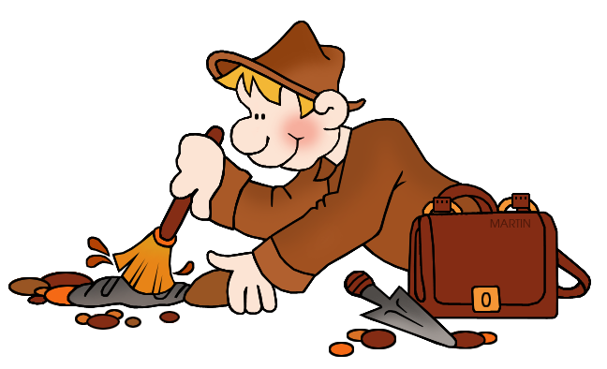
Appendix A- Archaeologist Reflection Name___________________
Be an archaeologist!
Now that you have had the opportunity to be an archeologist, write about your experience. Write a paragraph. Think about the questions below to help you with your paragraph.
- Compare your experience with the chocolate chip cookie to what it would be like to dig for Native American artifacts.
- What kind of tools do you think archeologists uses to “dig” into the past? Why?
- What are some character traits an archeologist would need to have to be successful digging up artifacts that have been buried for a long time?
- Do you think it is difficult to uncover artifacts from long ago? Why or why not?
_________________________________________________________________________________________________________________________________________________________________________________________________________________________________________________________________________________________________________________________________________________________________________________________________________________________________________________________

